Projet Waterproof

Week 1

. create a system which allows you to filtrate dirty water
. searching existent “water cleaning “devices
. mark down pros & cons of each project

Project | pros | cons
With chemicals | Kills bacteria easily / portable | toxic
UV light | Great technique to kill bacteria without having to use chemicals | Need a power supply
Boiling system | Cheapest project | Takes a lot of time + need to build a fire

Week 2

. Recap what we did last week + be more precise about what the project really is
. look for what already exists and what is missing
. What is the capacity of current project (≈ 0.5 L)
. How do they work
. Forgetting all projects with chemicals
. Finding the idea: a water cleaning device for emergencies like floods

Week 3

Going deeper into the technical aspect

. must be packable => size constraint
. must be light => weight constraint
. UV light system was the best one to use
. How do you power up the device? Emergency means no power
. We will have to use a dynamo
. How much water do we want our device to carry? (≈3L)

Week 4

Our first idea was a box

Cons:
. Not easy to carry
. Not an optimal design
. No packable

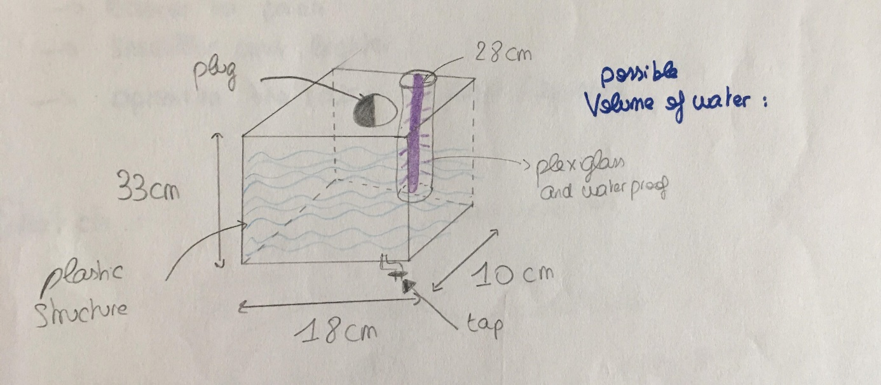

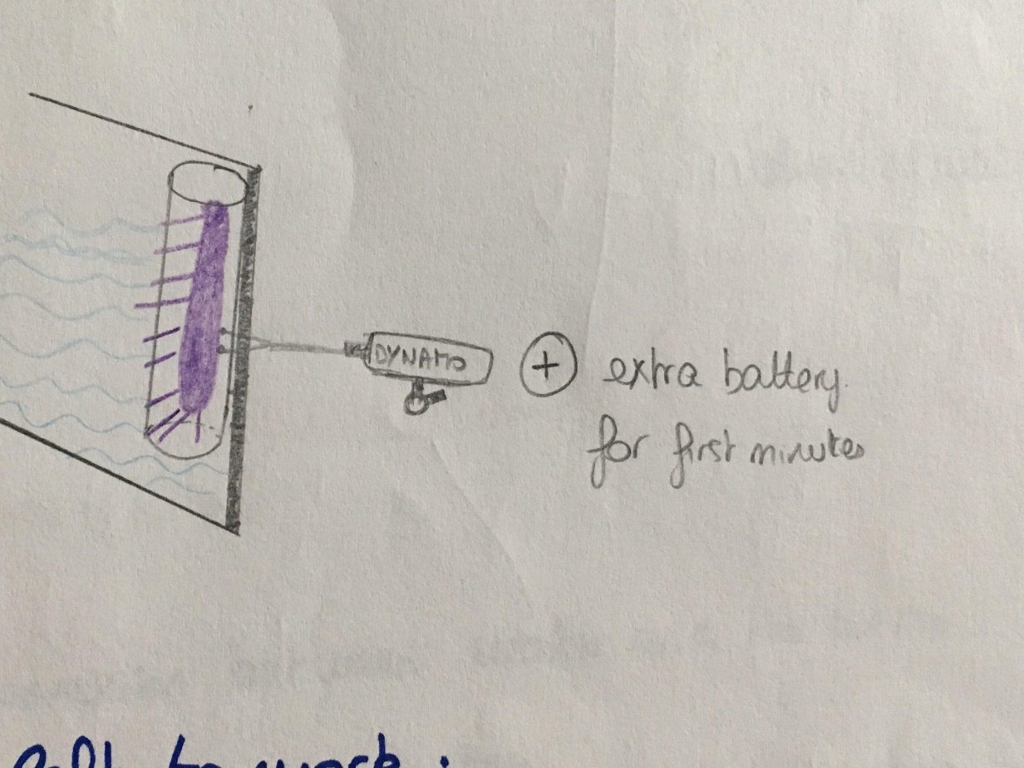

Problems left to work on:
. optimization
. wiring
. a first filter for mud

Week 5

Instead of a box we will use a cylinder. It is easier to pack, smaller and lighter but also optimize the ratio UV light per area.

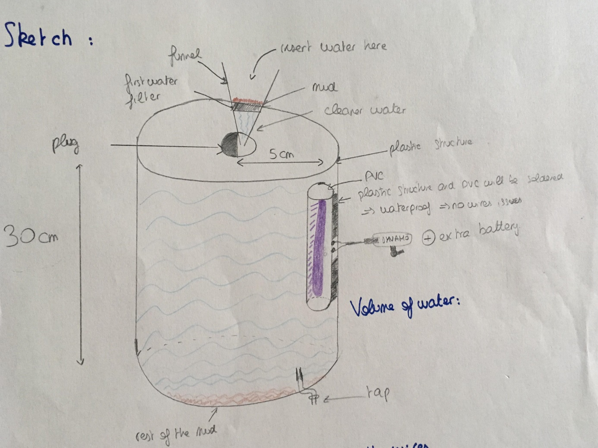

Pros:
. double filtration system
. the wires will not be in contact with the water

Week 6

We wanted to connect the UV light to the dynamo so when you are using the dynamo it does generate power to use the UV light. Unfortunately, there is a problem with the UV light, so we can’t use the UV light for the actual test. We will use blue LED to replace the UV light.
Here is a look on how the lighting system works.

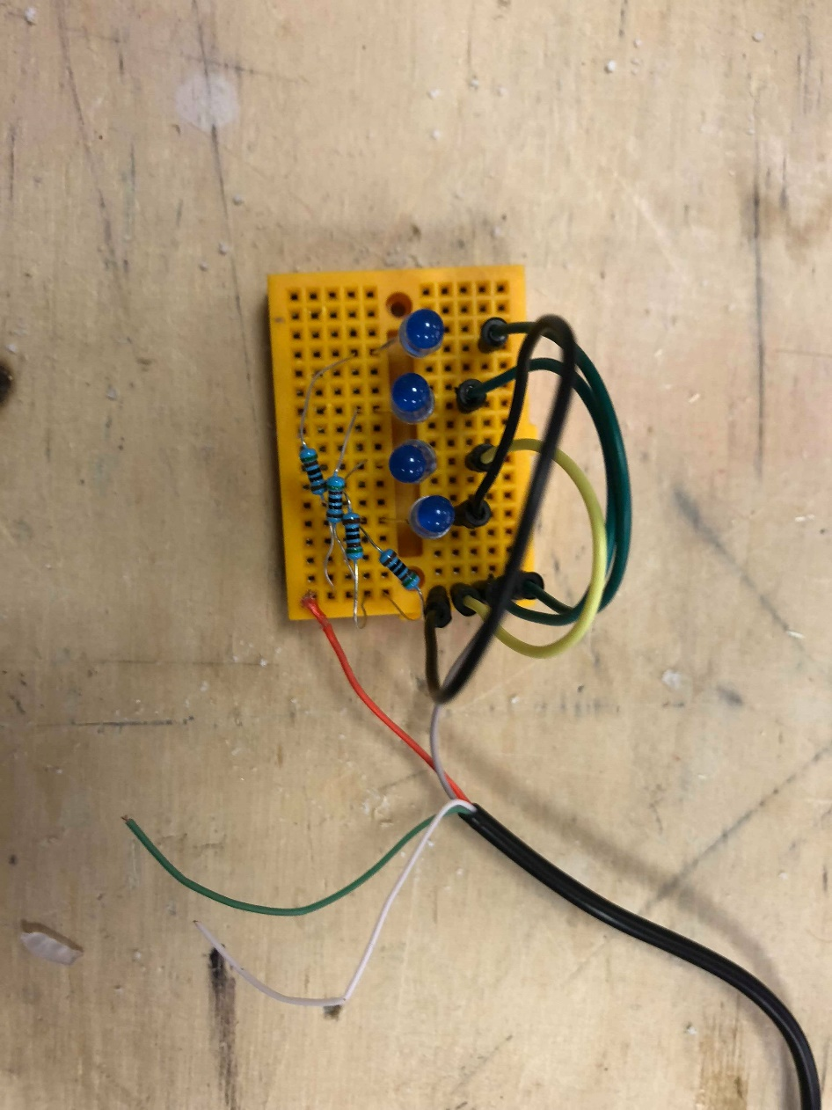
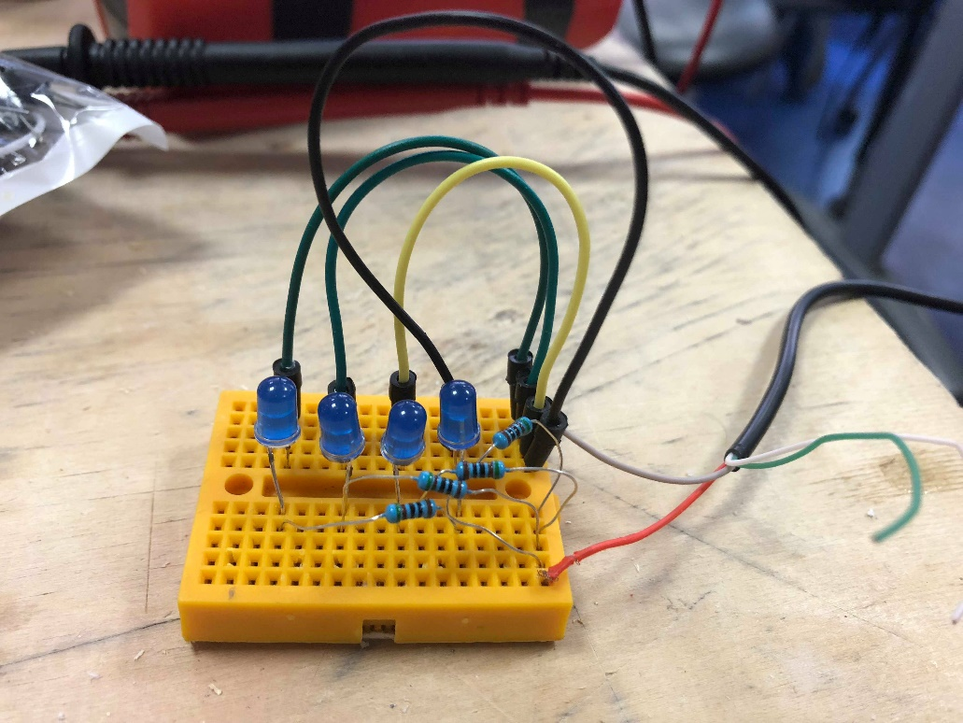
. 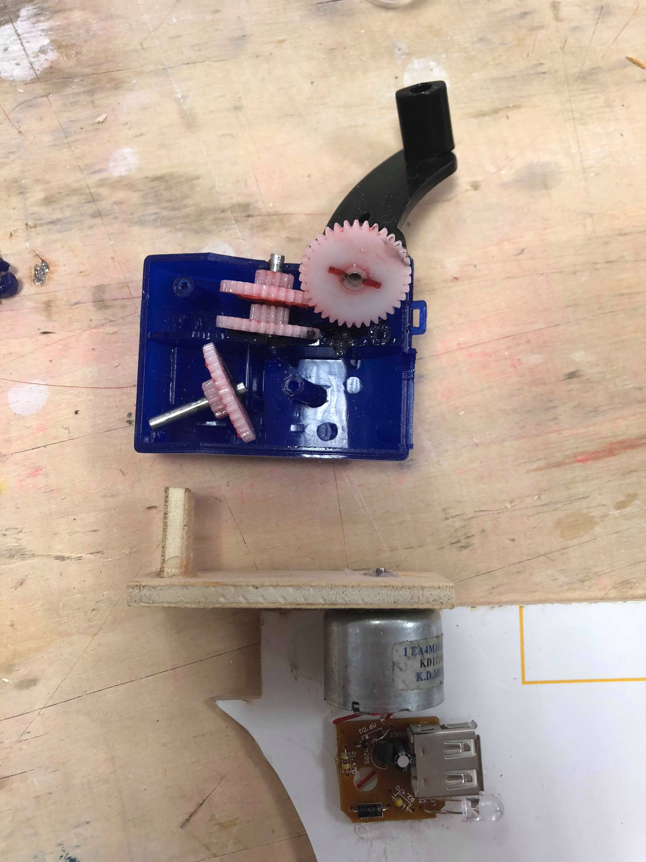

Week 7
Finishing the last details of our project.

